**UNIQUE Private High School**

**sdfsdf**

|  |  |  |
| --- | --- | --- |
| **GRADE_12** | **CHEMISTRY** | **TIME Allowed ( dfsdf )** |

|  |  |
| --- | --- |
| **1. Select the correct word(s), notation(s), term(s), unit(s), etc.., given in the brackets** | **( 5 marks)** |

a. There are _________ dumbbell-shaped p orbitals (Px, Py, Pz).A. two B. three C. four D. five

b. Electronegativity is _________.A. how good an atom is at attracting electronB. the ability of an atom to lose electronsC. the energy required to remove an electron from a specific atomD. how easy it is to make friends

c. All the substances listed are solid at room temperature. Which substance has a simple molecular structure?A. Sodium B. Iodine C. Carbon(graphite) D. Strontium

d. 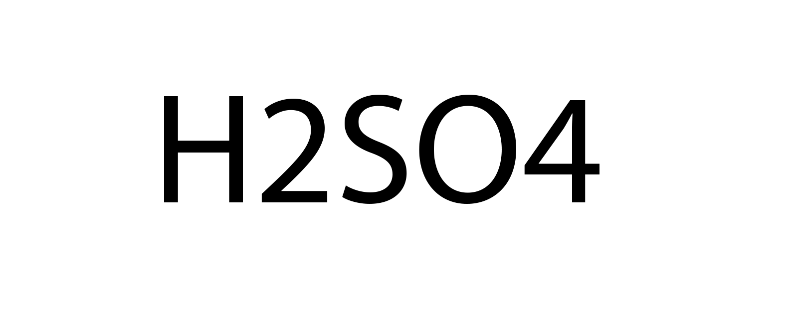 is the symbol for water.

e. All alkaline earth metals have ________ valence electrons and form ions with a ________ charge.A. 2, +2 B. 1, +1 C. 2, -2 D. 3, +3